Accurately Modeling Stability in OpenRocket

Step 1: Create an accurate OpenRocket file for your rocket factoring in as-built mass, center of mass, and moment of inertia.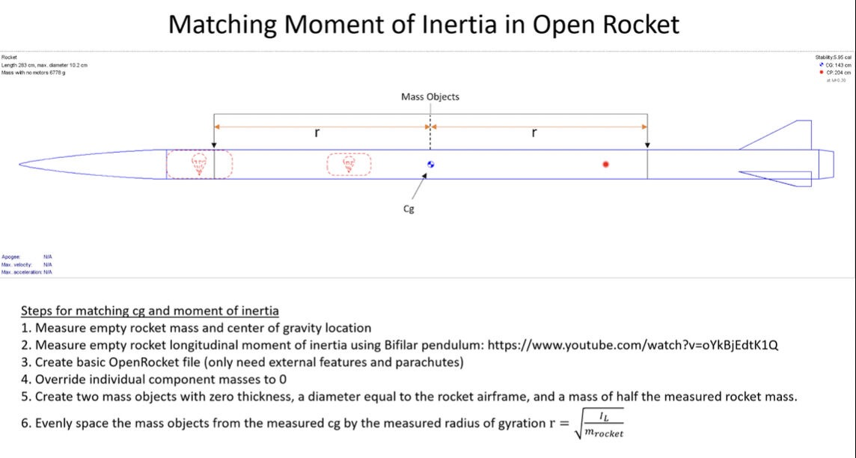
Step 2: Generate a .RSE file for your engine
- The process is similar between hybrids and liquids, just liquids will have an additional fluid component to model.
- The mass used in the .RSE file should be adjusted such that the total mass of the rocket and motor is accurate (i.e. if your measured rocket mass is with motor hardware, don’t re-count the mass of that hardware in your .rse file)
- The following slides explain how a .RSE file is defined and gives an example of how to estimate Cg location in your engine.
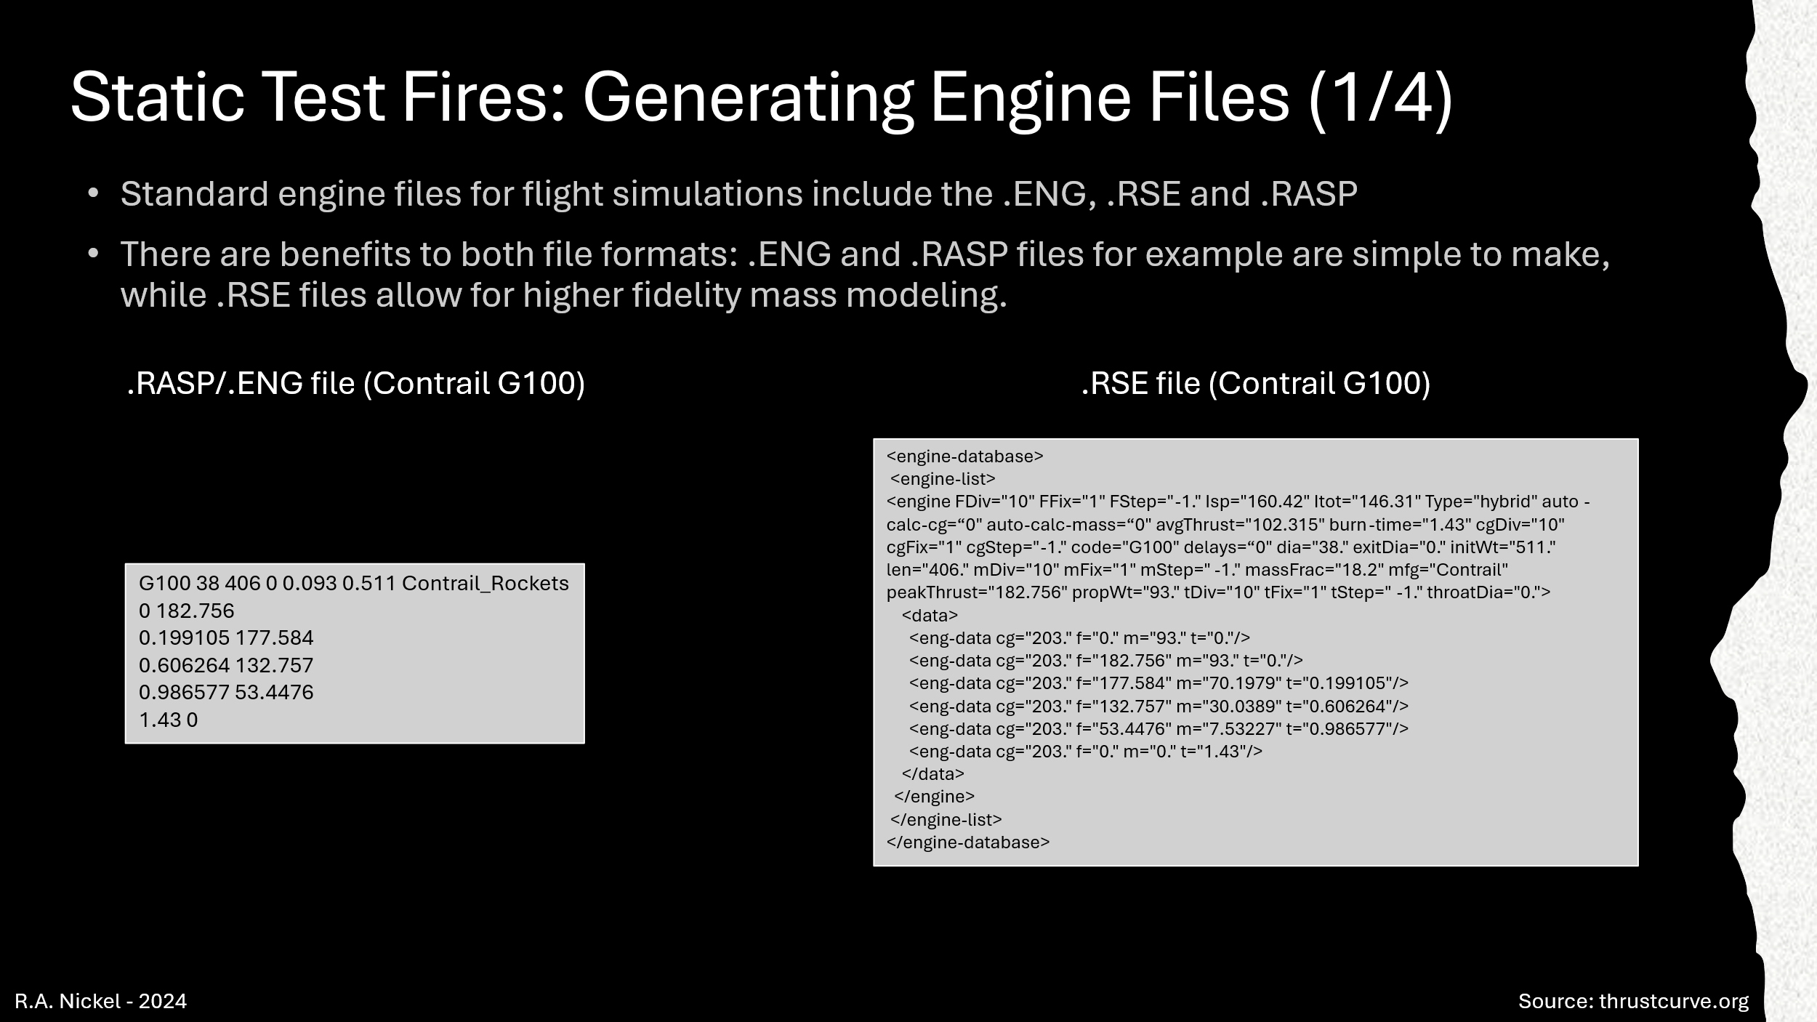
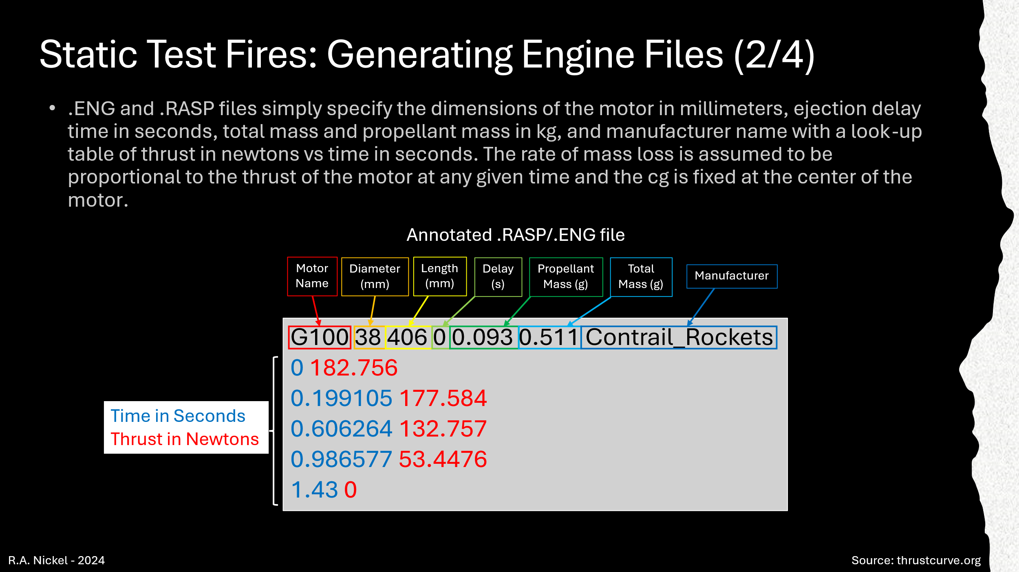
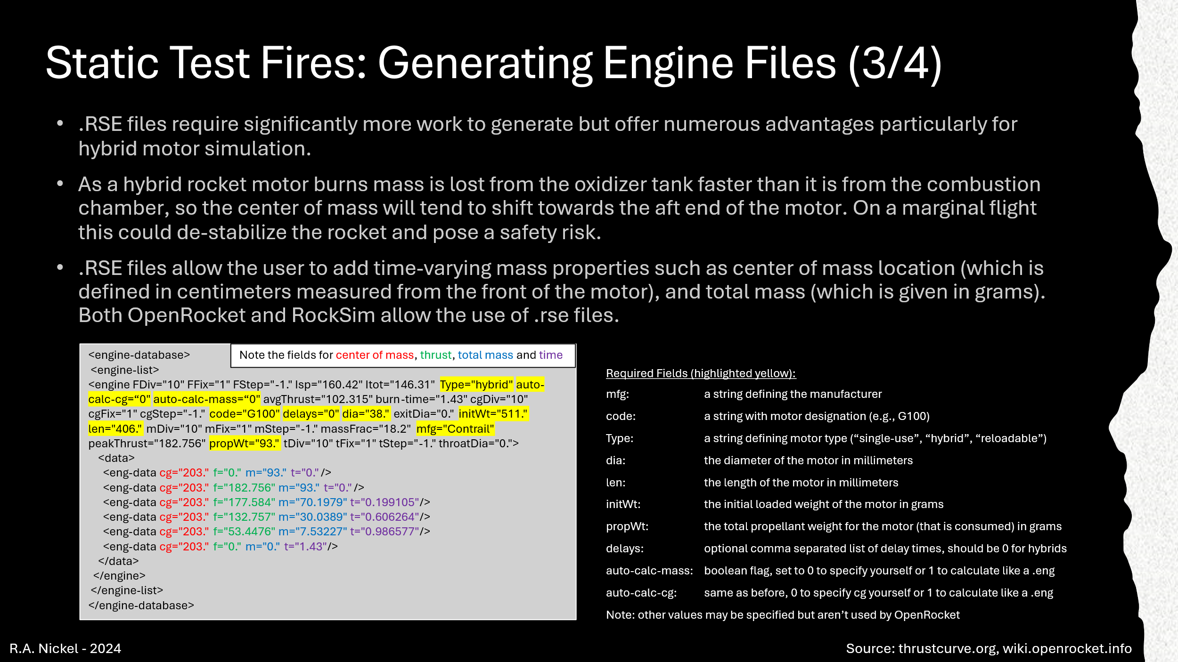
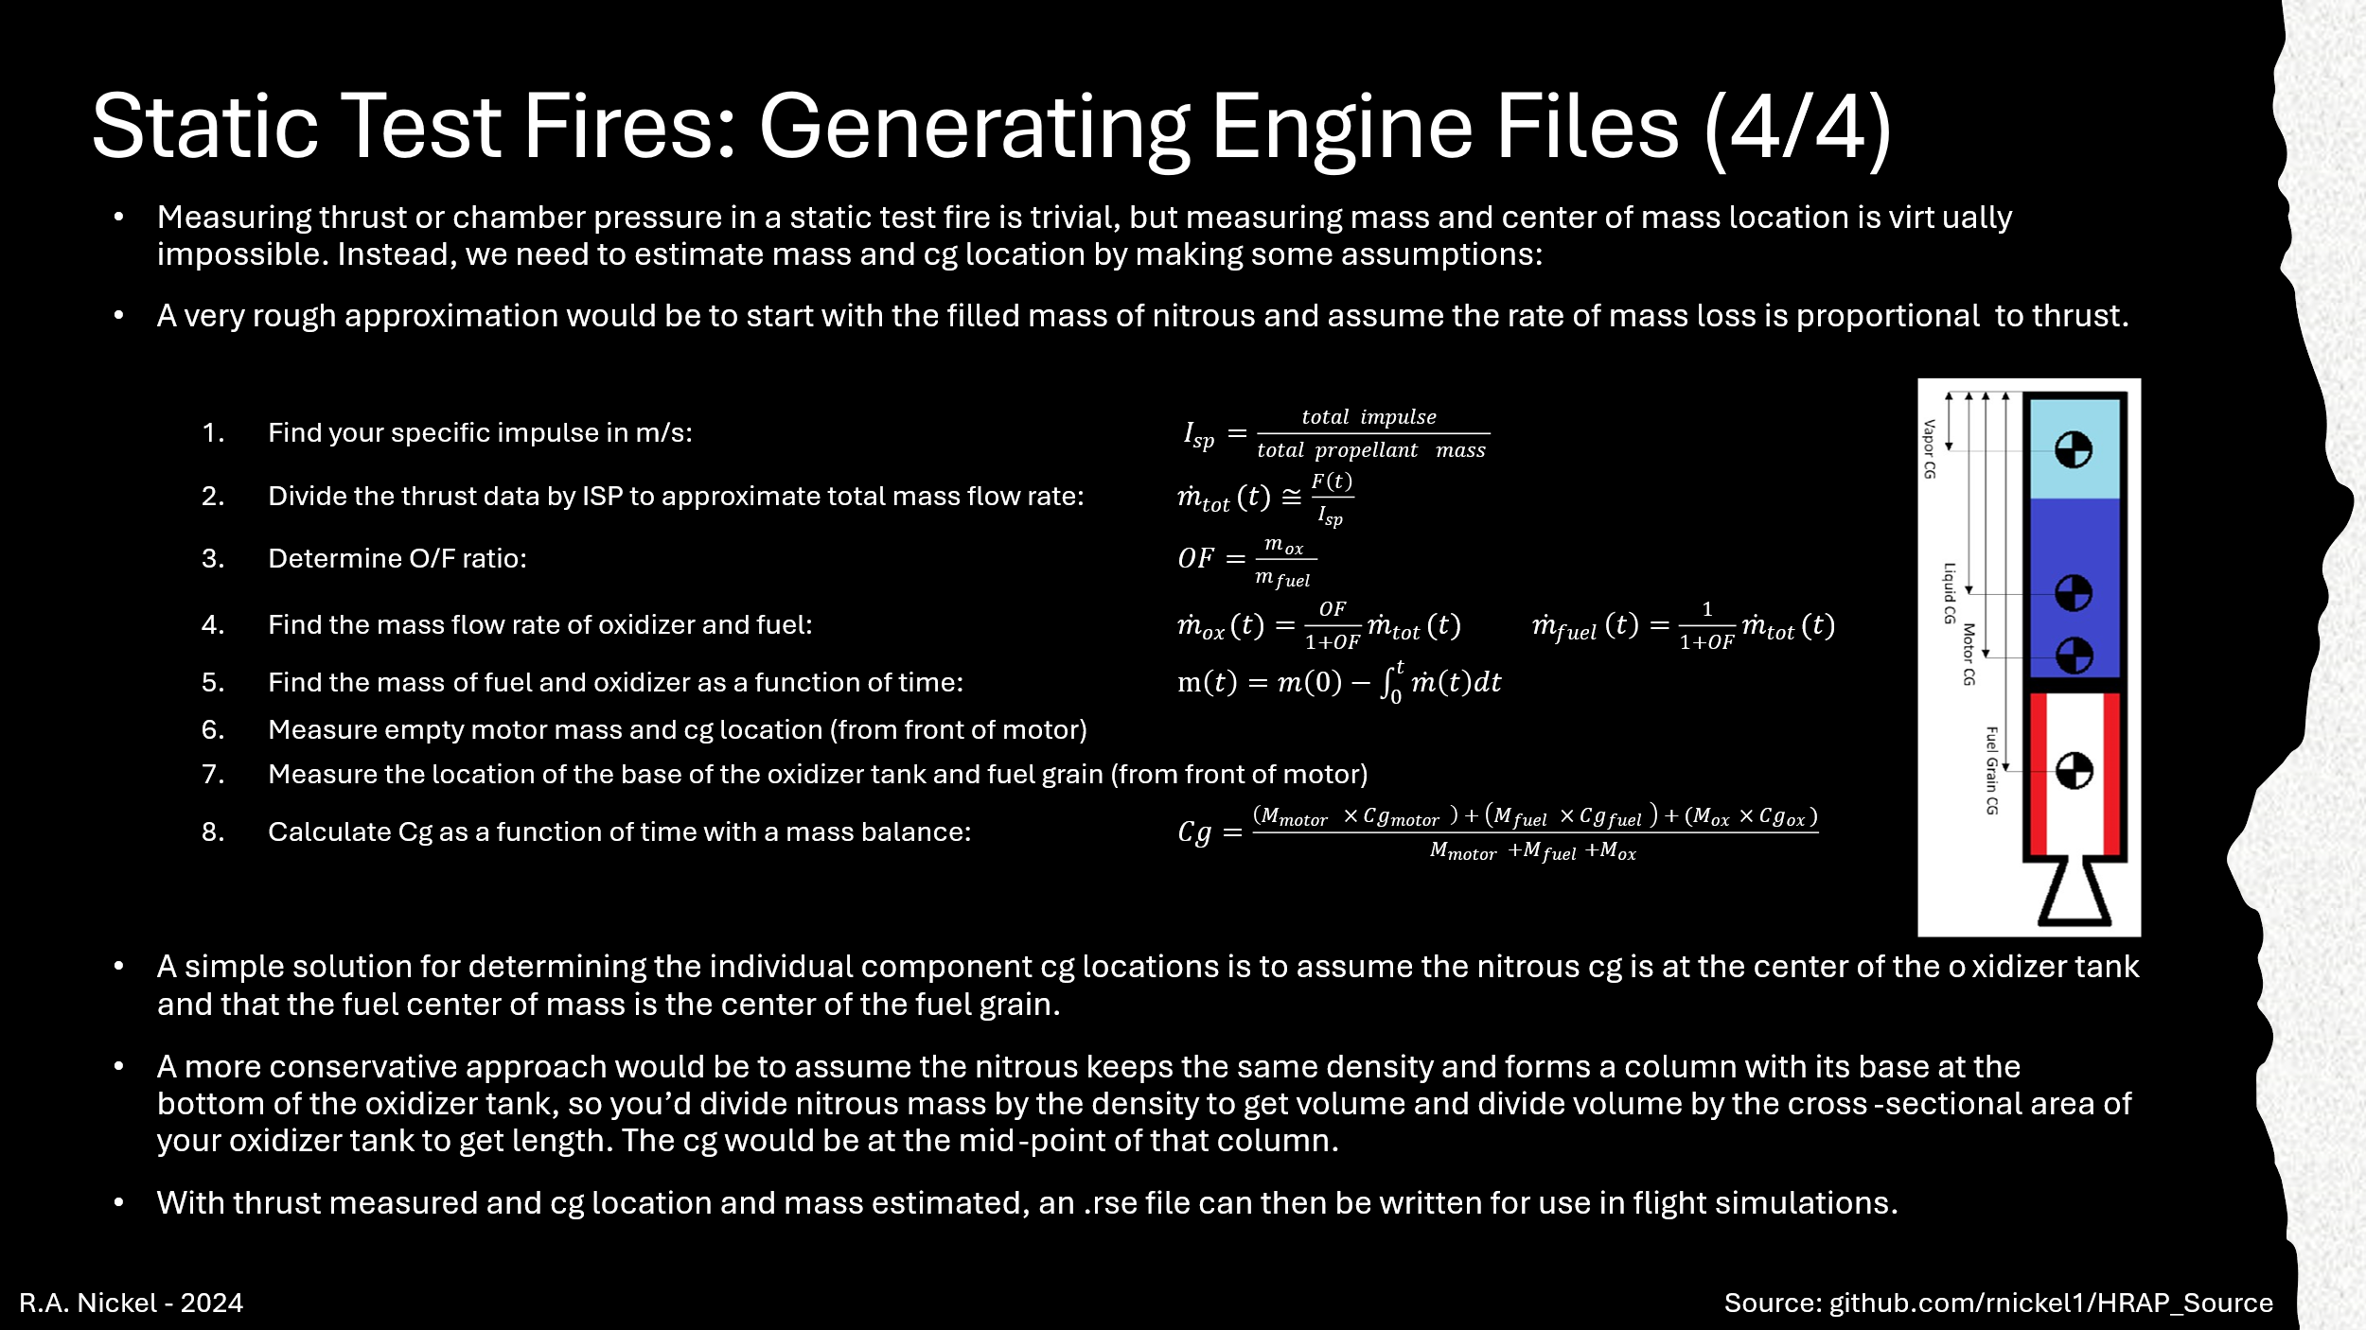
Step 3: Add the following custom expressions to your OpenRocket file as shown below (note: please use OR version 24.12, Damping ratio will not properly plot in earlier versions):
Go to the “Flight simulations” tab
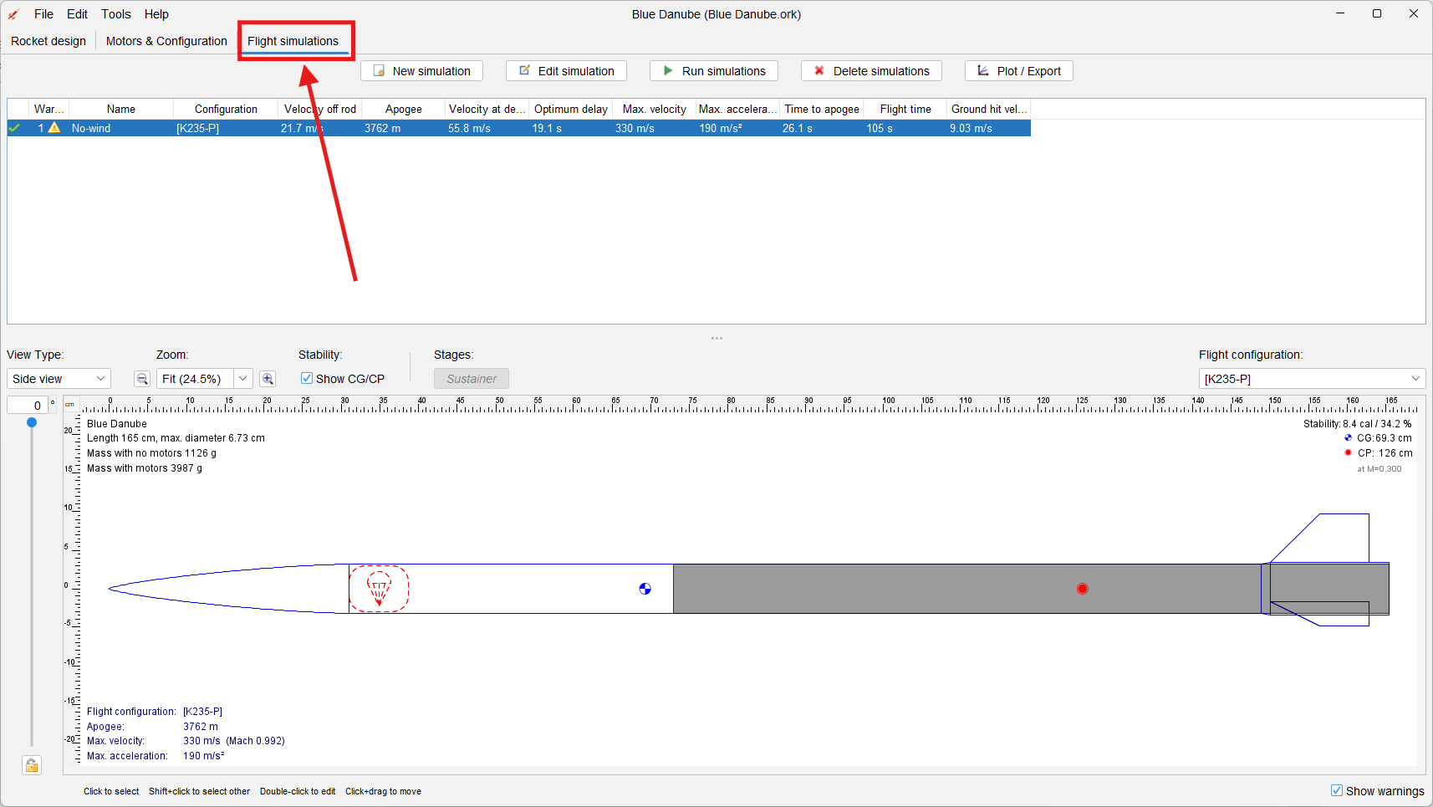
Go to “Edit simulation”
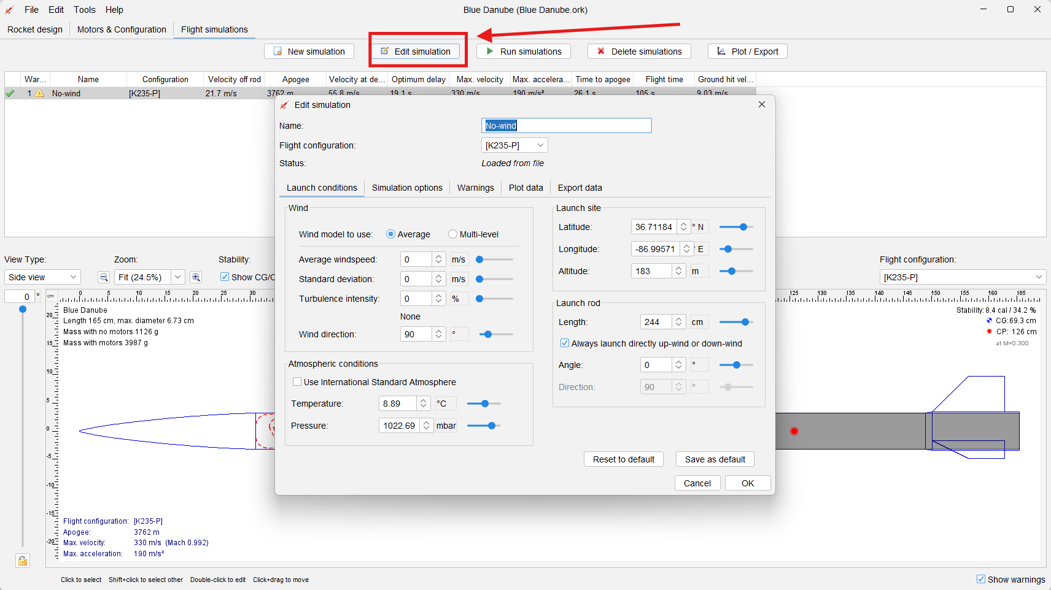
Go to “Simulation options”
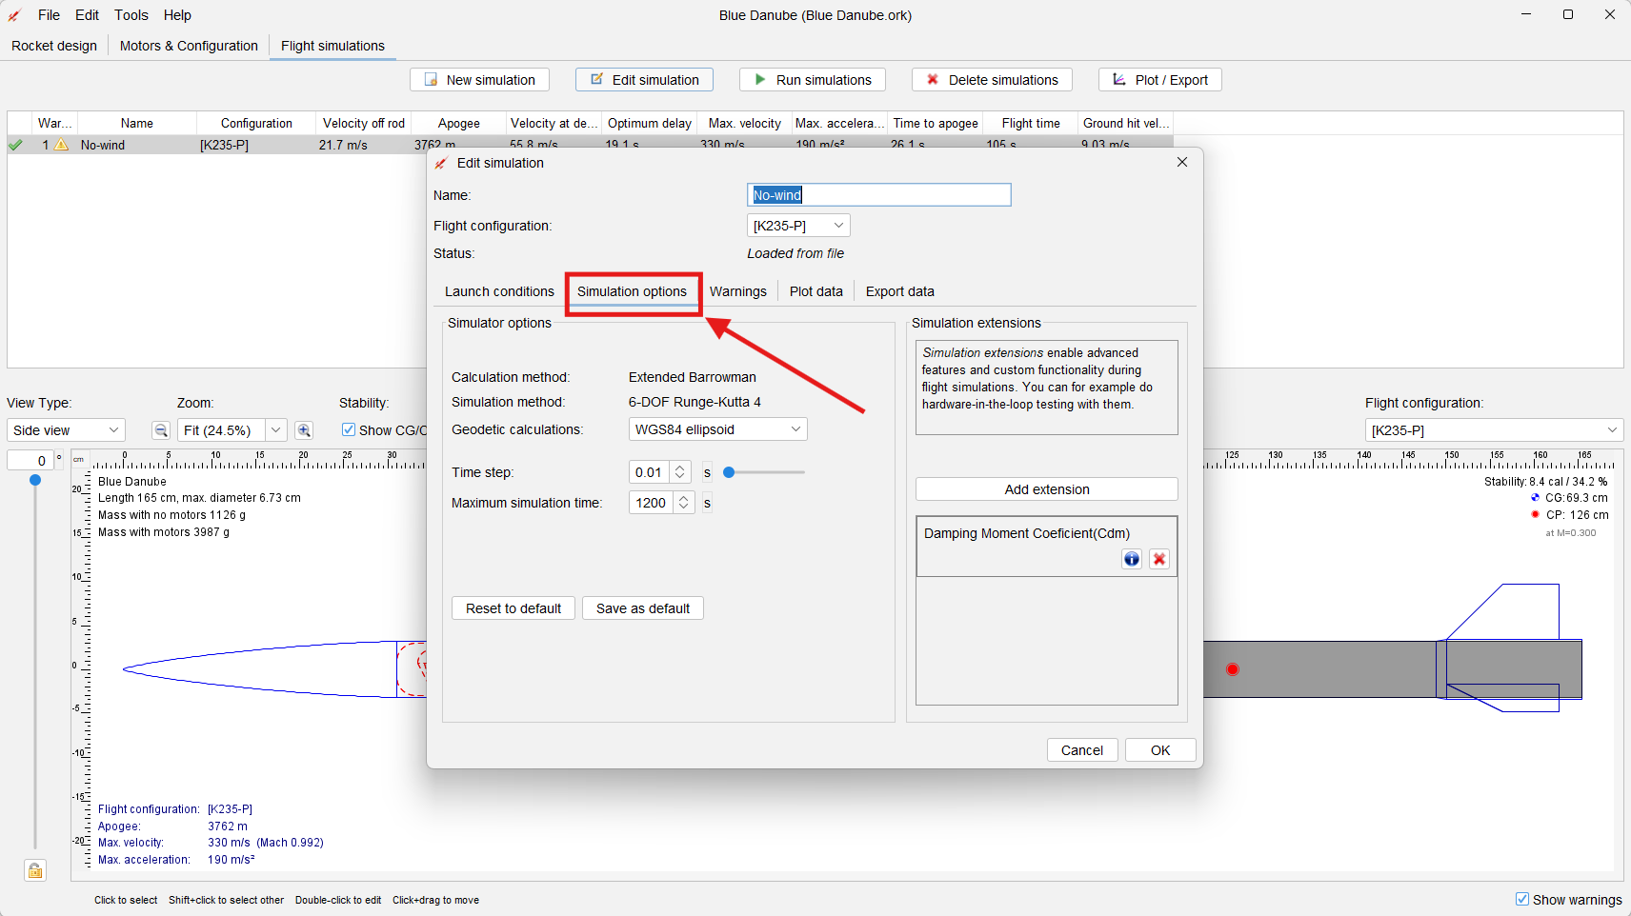
Go to “Add extension” then “Post-step flight conditions” then click on “Damping Moment Coefficient (Cdm)”. It should show up in the bottom right box on the “Simulation options” tab if you have done this correctly.
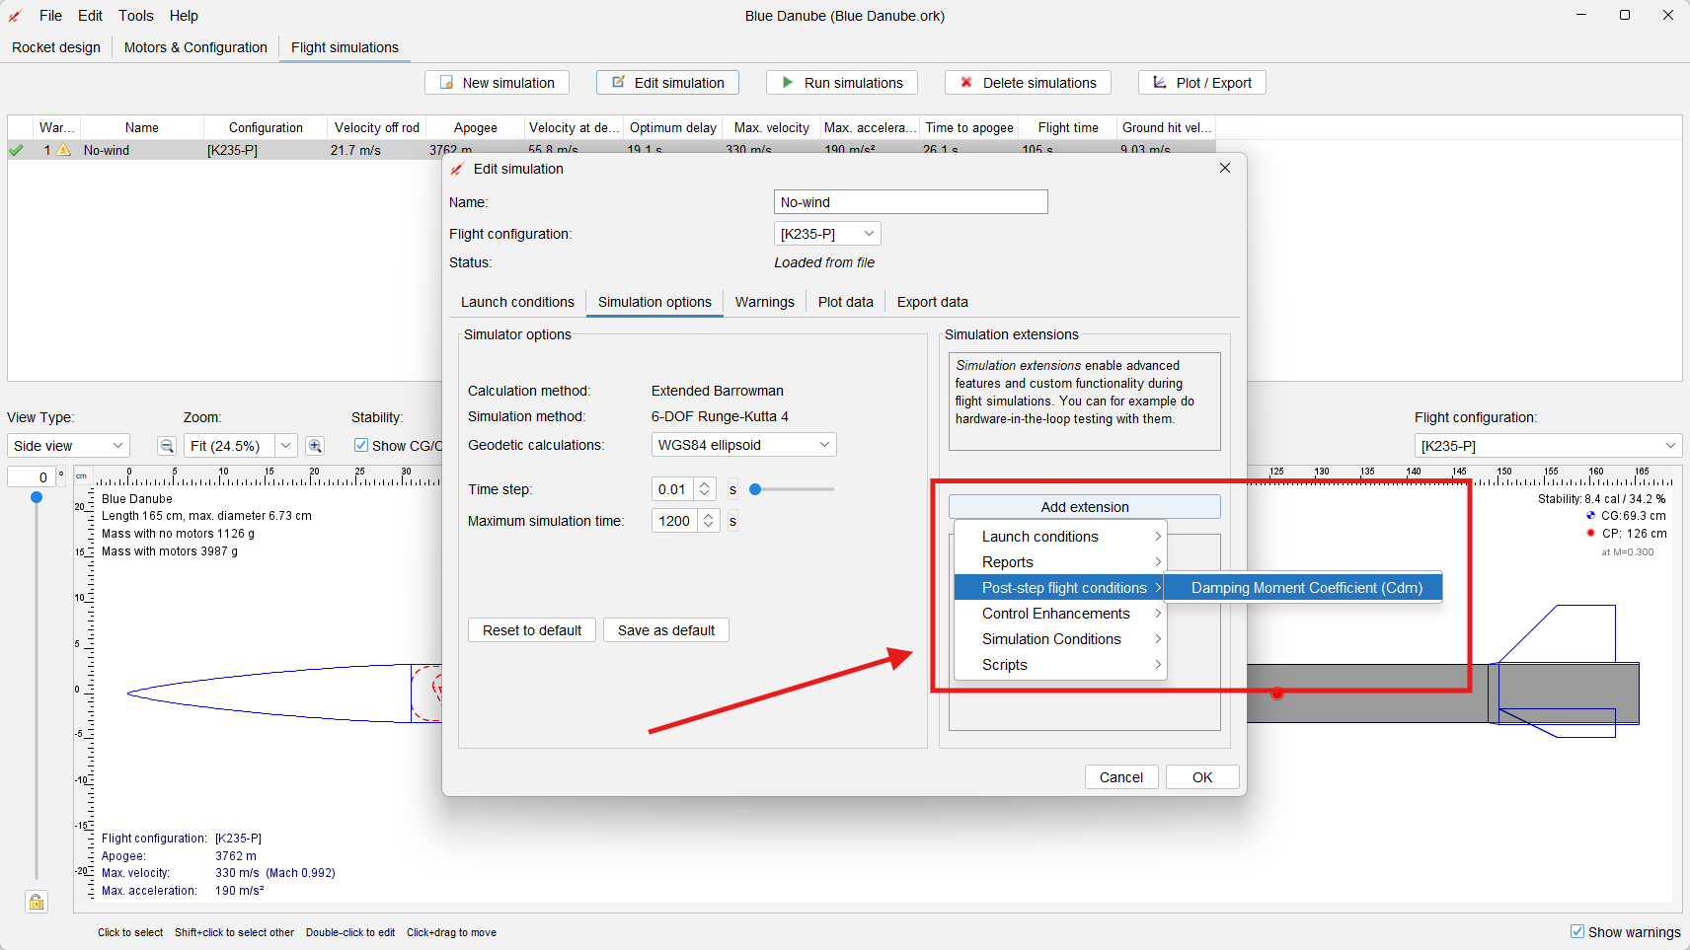
Click “OK” once that is complete and go to the “Tools” drop-down at the top left of the screen. Once there, click on “Custom expressions”:
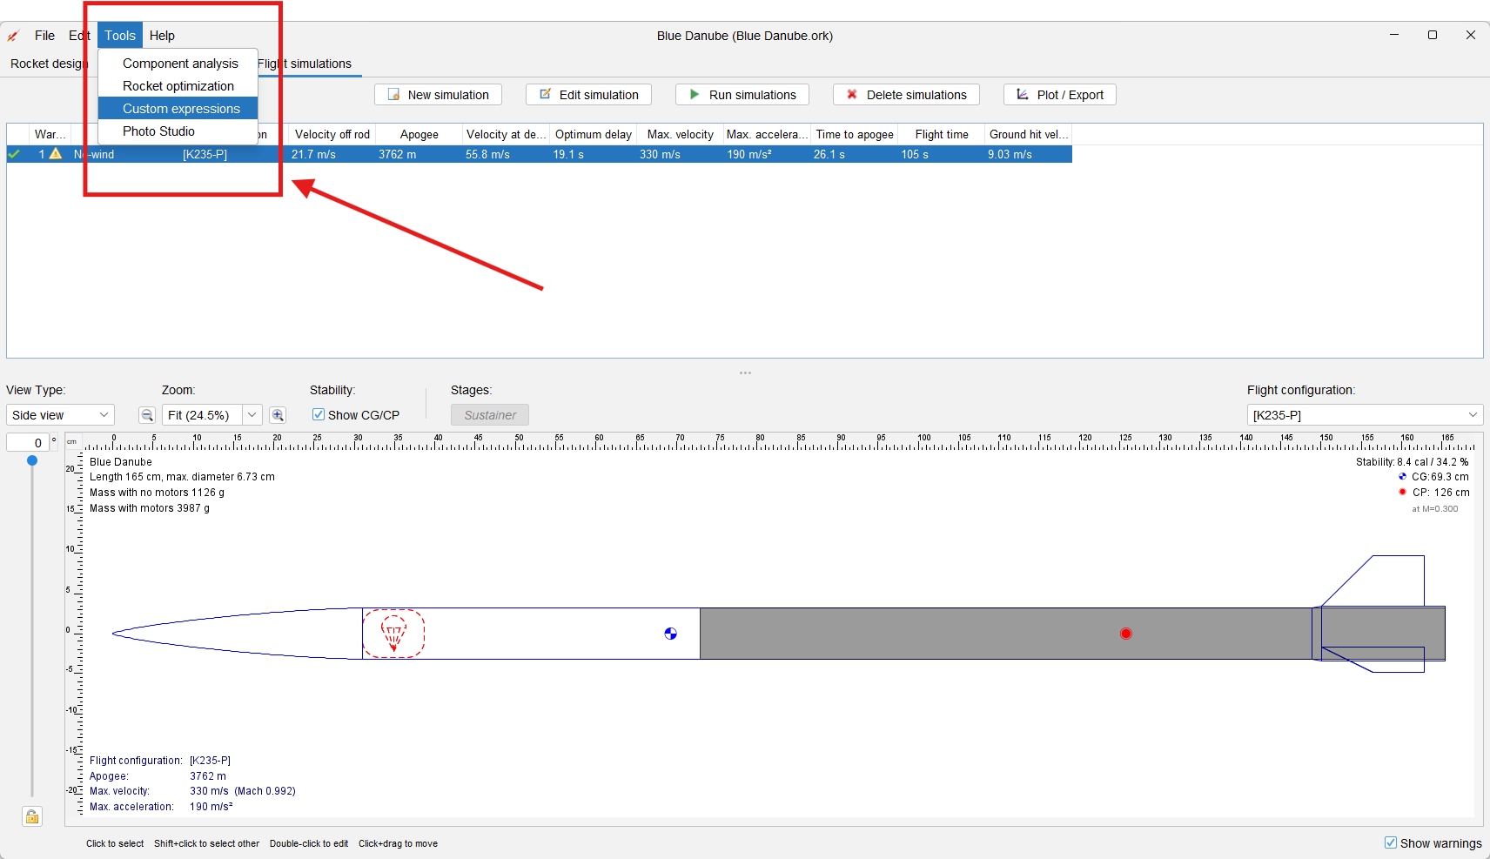
Add a new custom expression for Corrective Moment Coefficient. The Symbol should be Ccm, the units are in radians (dimensionless), the expression should be copy and pasted from this document as
Vt^2*Ar*(Cn/α)*(Cp-Cg)*(P/(287.058*T)) / 2
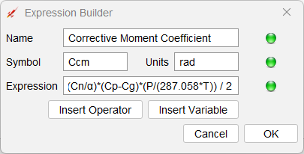
Run a simulation, if you do not you will see an error when trying to enter Damping Ratio as OR is looking for variables that does not exist until you run the sim. For Damping Ratio. The symbol should be /zeta , the units are again radians, the expression should be copy and pasted from here as
Cdm/(2*sqrt(Il*Ccm))
If you don’t run a simulation first, you’ll see a red circle at the bottom and won’t be able to add Damping Ratio
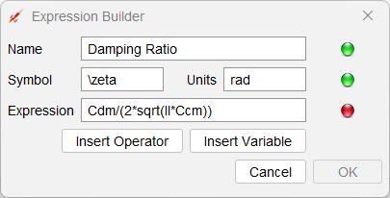
Once you run the simulation OR will see Cdm and Ccm as valid variables.
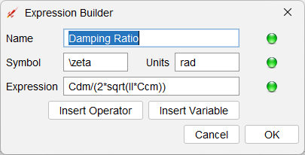
Finally, your Custom Expressions tab should look like this:
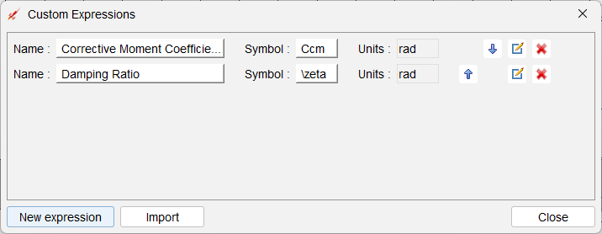
Now go run a simulation and plot Damping Ratio:
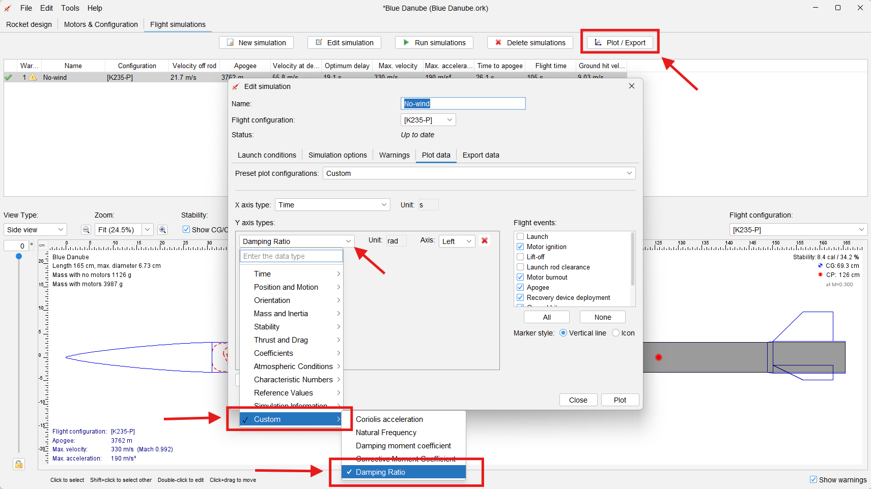
For plots of Damping Ratio vs time, please crop from Launch Rod Clearance to Apogee and make it easy to see. Your damping ratio should remain between 0.05 and 0.3 for the majority of the flight (it will grow rapidly near apogee as the rocket slows down begins to tumble). Below is an example plot of Damping Ratio, showing a flight with an acceptable damping ratio.
